

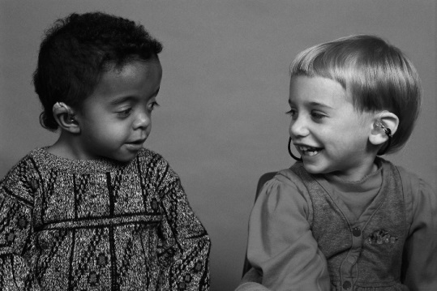

**How Are We Doing?**

**Looking at Child & Family Outcomes**

**What are Outcomes?**

Outcomes are the results children and families experience from participation in Early Intervention (EI). In addition to individual IFSP outcomes, Massachusetts looks at some broader Outcomes for all children. Just as they do for IFSP outcomes, families and providers work together to identify desired Outcomes and the services and strategies that will help to achieve these Outcomes

**Why Measure Outcomes?**

The Department of Public Health which oversees and regulates Early Intervention services in Massachusetts is required to measure and report on a set of Outcomes identified by the Individuals with Disabilities Education Act (IDEA). These Outcomes are designed to measure how well Early Intervention services work for children and families. Massachusetts reports this information in the Annual Performance Report to the federal Department of Education, Office of Special Education Programs.

**What's Being Measured?**

**For Children**

* Children have positive social relationships
* Children acquire and use knowledge and skills
* Children take appropriate actions to meet their needs

**For Families**

* Effectively communicate their children's needs
* Help their children learn and develop
* Know their rights

**How is this Information Gathered and Used?**

Information about child Outcomes comes from formal assessments, observations of children busy with everyday activities and from talking to you and other caregivers and professionals involved with your child and family. Family Outcomes come from the NCSEAM (National Center for Special Education Accountability Monitoring) Family Survey completed by families once a year. This information helps the EI system know if we are making a positive difference for children and families and how we can improve services.

For more information about efforts to measure Outcomes, contact the Part C Early Intervention Program at the Massachusetts Department of Public Health, 617-624-6060 or at [www.mass.gov/dph/earlyintervention](http://www.mass.gov/dph/earlyintervention)

10/2010