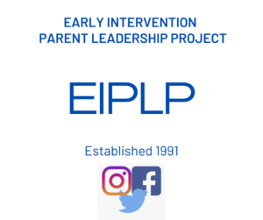
Contact the EIPLP or send form electronically

Toll-free: 1-877-353-4757
Email: eiplp@live.com
Visit www.eiplp.org

Please return signed form to:
Liz Cox

liz.cox@eohhs-sfed.state.ma.us

Early Intervention Parent Leadership Project Release Form

I hereby give permission for the Early Intervention Program to release my contact information to the Early Intervention Parent Leadership Project, funded by the Massachusetts Department of Public Health, to be added to their mailing list to receive The Parent Perspective Newsletter and other periodic mailings about workshops, meetings, and opportunities for involvement for families. If I choose to share my email address, I understand that I will receive all information electronically. The mailing list is confidential, and information will not be shared with other organizations.

Parent’s Signature

Print Parent’s Name EI Program Name

Email

Address

City, state, zip code

__________________________
Phone number Date

